

Referral and Letter Templates
SystmOne
User Guide

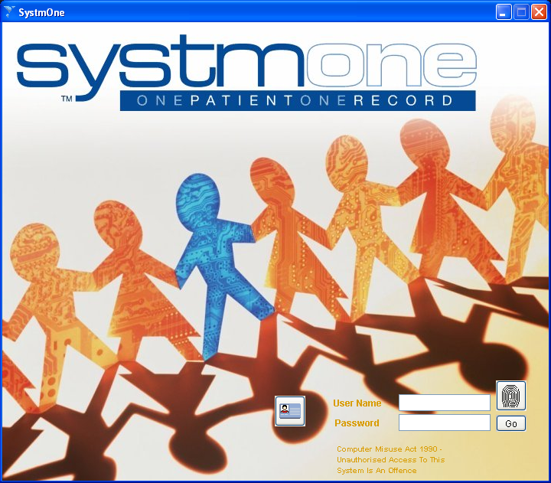

The SystmOne Training Team

Contents

Section 1: Creating a *New* Referral Template 3

Section 2: Creating a New Word Referral Template 6
2.1 Creating a Blank Word Referral Template 7
2.2 Make an existing Word Document into a Word Referral Template 8

Section 3: Sending a New Word Referral from a Patient Record 13
3.1 Sending a Letter from a SystmOne Template 16

Appendix A: Referral Data Standards 20

Section 1: Creating a *New* SystmOne Letter Template

- Click on the Setup menu at the top of the screen

- From this drop-down list select Referrals & Letters

- Select *New* Letter Template

- Click on the button in the top left corner labelled New Letter Template. The following screen is displayed.

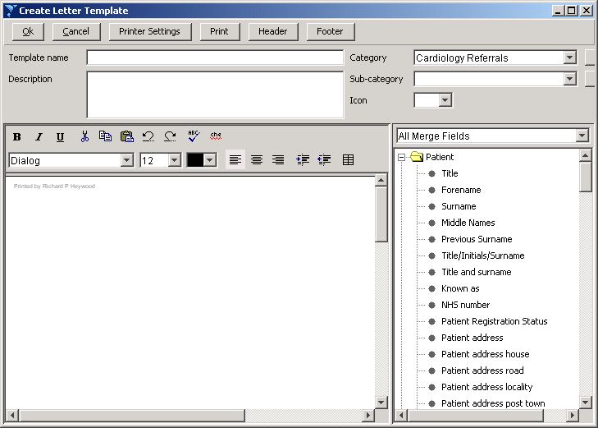

The information at the top of this screen needs to be completed.

- You are required to enter a Template Name, this should reflect the purpose of the template

- A description of the template is optional, although any important relevant information can be entered here

- Select a Category and Sub-category as applicable. Further options can be created, by clicking the “New Category” button.

Note: It is important to ensure letter templates are categorised in an appropriate way, this makes use of these letters easier when applying to a patient record.

- The body of the letter can be then entered in the main window on the left hand side. The toolbar at the top of this window allows for the basic level of Word Processing editing tools. Once the body of the letter has been entered and formatted as required, the merge fields can then be added.

- The list on the Right-hand side of the screen lists all the available Merge Fields that can be imported into the template. These can be filtered by type using the drop-down list. To import a merge field into the document, double click on it. These fields can be moved around the body in the same way as normal text.

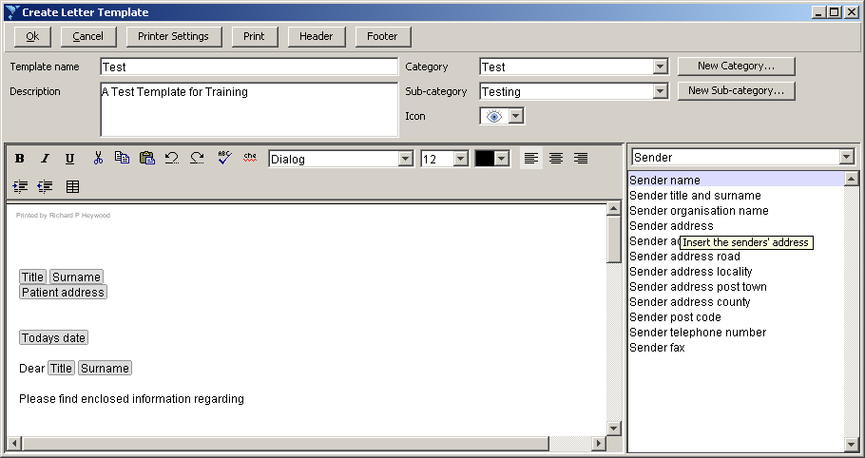

- The header and footer buttons and the top of this screen also allow for the text that appears at the very top and bottom of the page to be edited. When clicking on either of these options, the following screen is displayed.

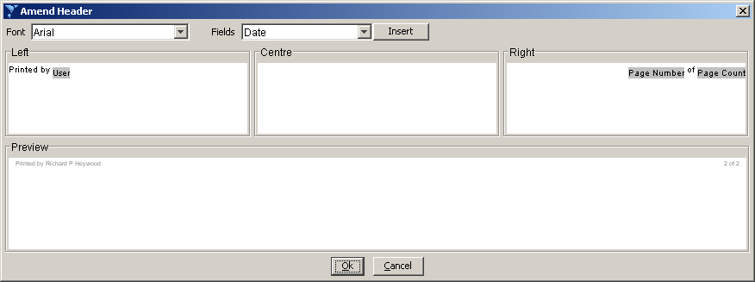

- Text can be added here that will appear at the bottom or top of every template. When right clicking in any of the three boxes referencing Left, Centre and Right, a number of options are displayed, that will allow fields such as date, page number and patient details to be automatically imported. A preview is shown also. Click OK to accept these changes.

Section 2: Creating a New Word Referral Template

- Click on the Setup menu at the top of the screen

- From this drop-down list select Referrals & Letters

- Select *New* Word Letter Template

- Click on the button in the top left corner labelled New Template

- The following window is now displayed

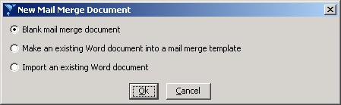

The table below details the implications of each option.

Blank mail merge document | Allows a Word Letter Template to be created from a blank sheet
Make an existing Word document into a mail merge template | Add merge fields to an existing document for use within SystmOne
Import an existing Word Document | Import an existing document that already has all required merge fields in it.

Note: Unless merge fields are labelled in exactly the same way as SystmOne recognises them, a template may not be fully functional. Therefore it is advised that unless completely sure, users should not select the option to “Import an existing Word Document”

- Select the most appropriate option from this window and click “OK”.

2.1 Creating a Blank Mail Merge Document

- A blank document is opened in Microsoft Word, which can now be edited as required, in the same way a normal Word Letter would be.

- Once the letter has been created, merge fields need to be added into the document in the appropriate places. To do this click on the “Insert Merge Fields” icon on the Mail Merge toolbar as shown below.

Note: If the Mail Merge Toolbar is not currently viewable to you, click on View > Toolbars > Mail Merge at the top of the Microsoft Word window, and it will appear as a toolbar at the top of the screen.

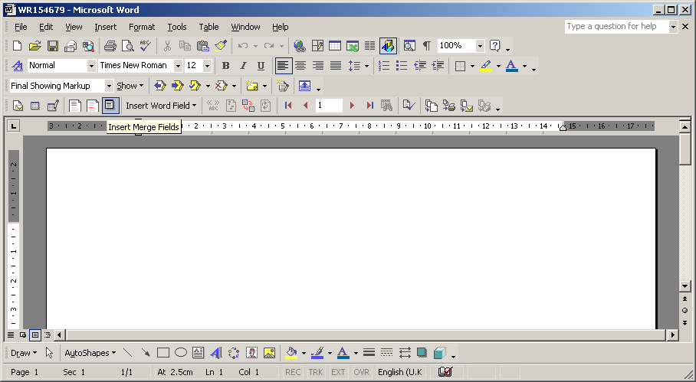

- The following list of Mail Merge options is now displayed. To insert the desired merge field, double click on it from the list. The fields will then be imported in the document, in the format of «FIELD NAME»

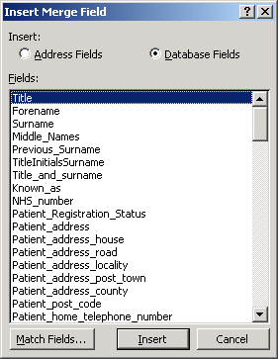

- Once all the desired merge fields have been entered into the document, you can close or click cancel on this window

- Any further formatting or design changes can now be made to the document.

- Once the document has been created as required, click on X to exit out of Word this will then prompt you to save the document. Click on Yes which will then return you back to SystmOne.

Note: It is important that users do not choose “Save As”, as the names generated for the documents by SystmOne allow it to reference the location of the document.

- You will then be returned to the SystmOne window and will be presented with this dialogue box. Here you can enter a Template name and Description as well as selecting a Category and Sub-category as appropriate.

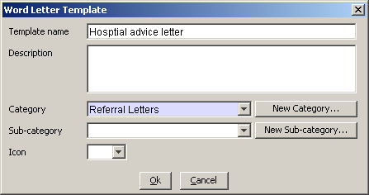

- Once this window has been completed, click “OK”. The template you have created will now appear in the list of templates.

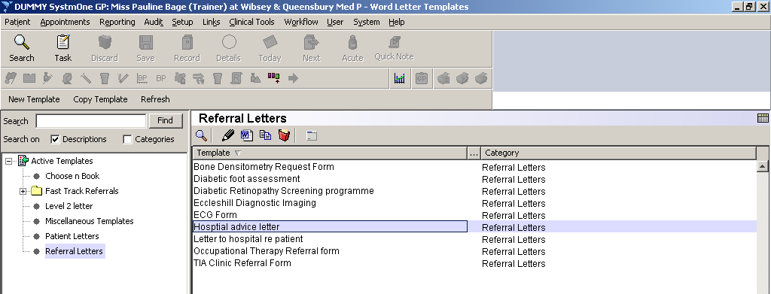

2.2 Make an existing Word Document into a Mail Merge Template

- If selecting the option to “Make an existing Word Document into a Mail Merge Template”, you will first be presented with the following File Browser Window. Use this window to navigate to the location of the already saved Word document on your Documents or Shared Drive.

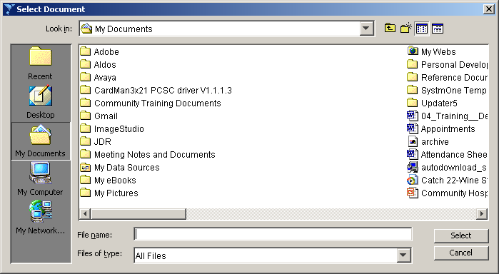

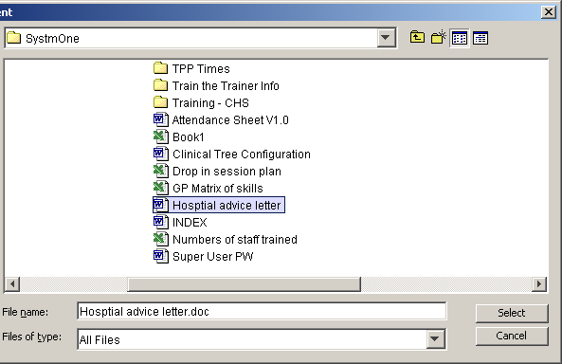

Once the file has been located, double-click on it in the file list. You will be presented with the
following information window. It is important to note down the location that is given on this window.
In this case the location is c:\apps\tpp\temp\MergeSource.csv

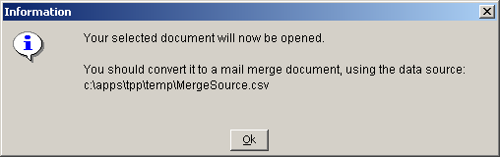

- In order to insert the merge fields that SystmOne uses, we are now required to open the Data Source, as referenced in the previous window. To do this, click on the button to “Open Data Source” in the Mail Merge Toolbar, as shown below.

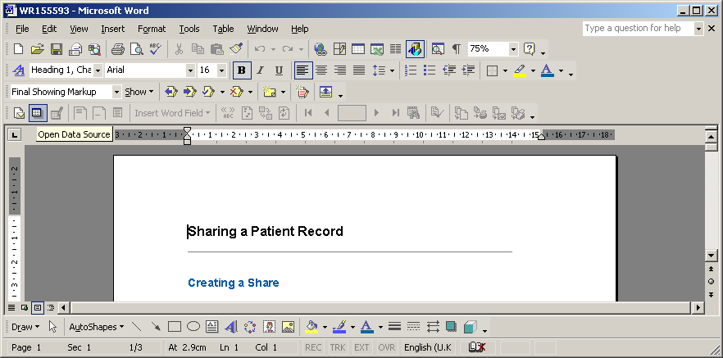

- The following File Browser window is now displayed. Use this screen to navigate to the Data Source file as detailed above.

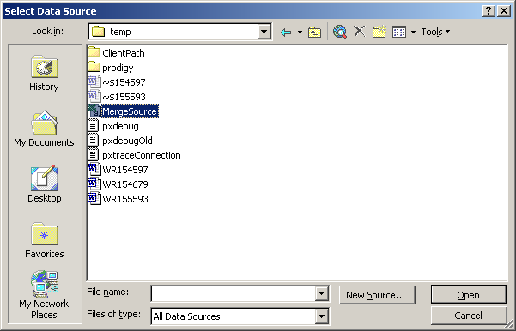

- You will now be able to insert Merge Fields from SystmOne. To do this click on the “Insert Merge Fields” icon on the Mail Merge toolbar as shown below.

Note: If the Mail Merge Toolbar is not currently viewable to you, click on View > Toolbars > Mail Merge at the top of the Microsoft Word window, and it will appear as a toolbar at the top of the screen.

- The following list of Mail Merge options is now displayed. To insert the desired merge field, double click on it from the list. The fields will then be imported in the document, in the format of «FIELD NAME»

- Once all the desired merge fields have been entered into the document, you can close or click cancel on this window

- Any further formatting or design changes can now be made to the document.

- Once the document has been created as required, click on X to exit out of Word this will then prompt you to save the document. Click on Yes which will then return you back to SystmOne.

Note: It is important that users do not choose “Save As”, as the names generated for the documents by SystmOne allow it to reference the location of the document.

- You will then be returned to the SystmOne window and will be presented with this dialogue box. Here you can enter a Template name and Description as well as selecting a Category and Sub-category as appropriate.
The template name will import with a .doc extension, please delete this

- Once this window has been completed, click “OK”. The template you have created, will now appear in the list of templates.

Section 3: Sending a Word Referral from a Patient Record

- Retrieve the patient record that you wish to send the referral from

- From the record, click on the node labelled Referrals in the clinical tree.

- A list of any referrals that have already been sent from the patient record is now displayed.

- To create a Word Referral from the patient record, click on New Word Referral icon at the top of the window or right click on the Referral node and select New Word referral.

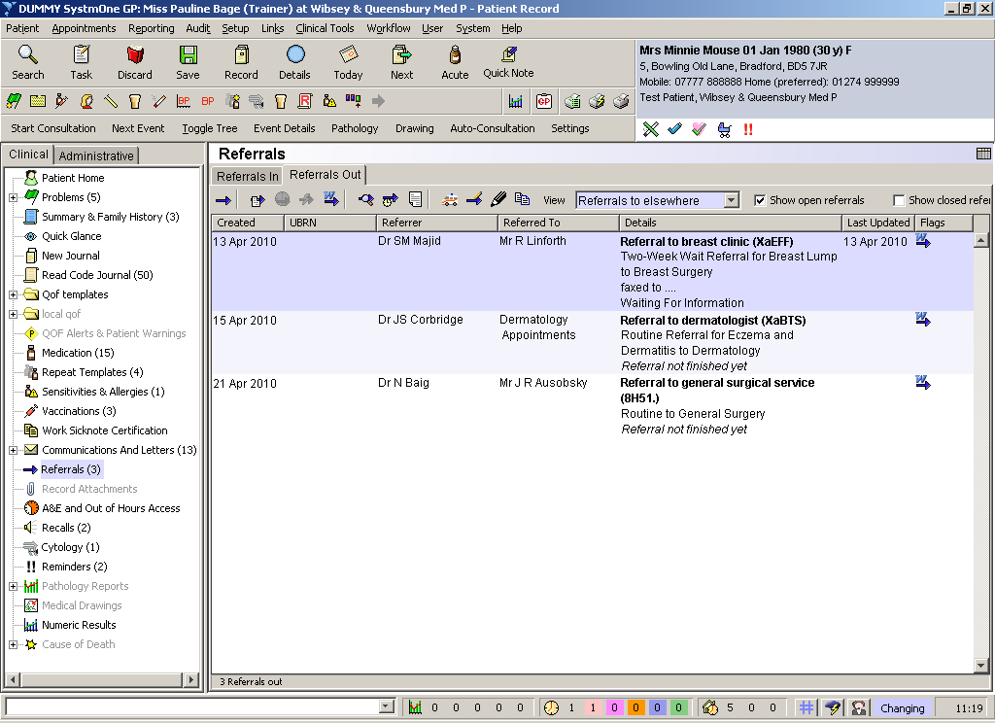

- The following window is now displayed, which allows you to link the referral through to the problem from a dropdown selection. You will also need to change the Referrer details from the dropdown menu on the next line of the dialogue box.

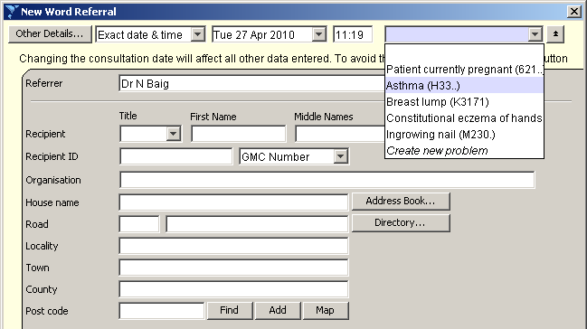

- There is a button for Address Book, click once to access the address book. There is a Search tab at the top of the screen with a search box. Type in either the department, name of consultant or ward number. This will give you the result of the search in the dialogue box below. If the required address/consultant is in the list click once on the appropriate address/consultant and then click select.

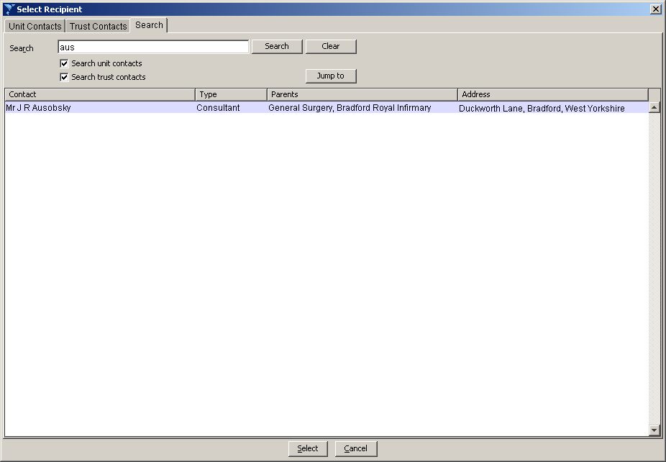

- This populates the recipient details and if the address book is setup correctly, the read code for the relevant clinician/department.

- There is also a directory to choose an address from within the search facility. NB – this does not add the read code to the referral at this stage.

- If neither of the above is suitable, you can search on the post code and add the address in manually. NB – this does not add the read code to the referral at this stage.

- You can also choose the reason for the referral and service requested and the urgency within this screen, and at the very bottom of the screen “Choose Template”

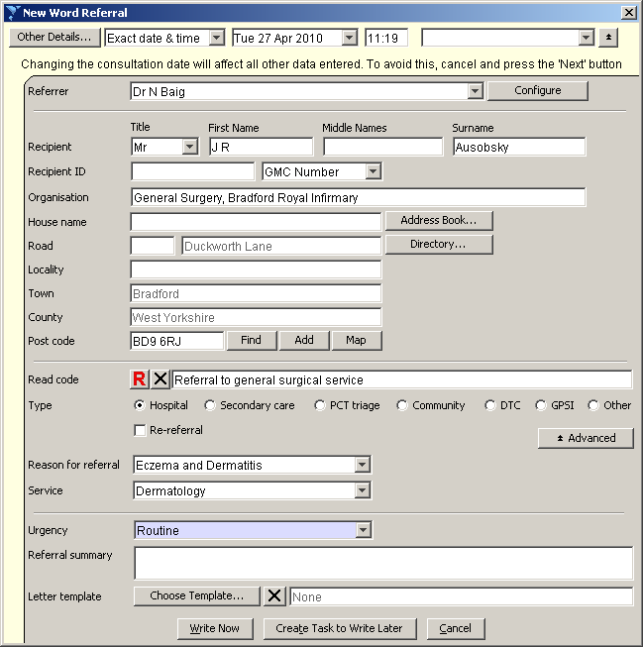

- The “Choose Template” window is now displayed. This will show a list of all the templates that are available for use in your organisation. Double click on the required Template to select.

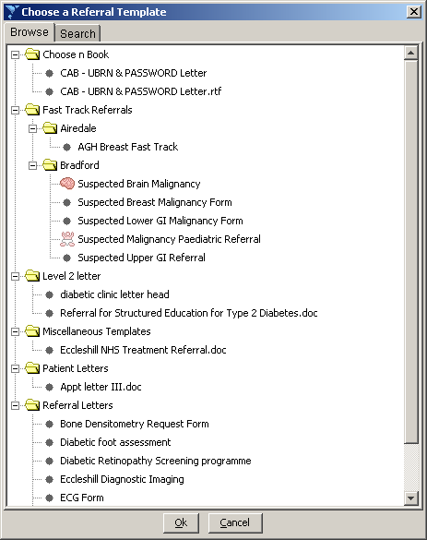

- The name of the Template will now appear in the previous window, under the “Template” heading. Once all of the information is correct on this screen, click on the “Write Now” button.

- You will get another dialogue box as below – ok this as the Practice will not know any of the consultants/department ID for Acute Hospitals

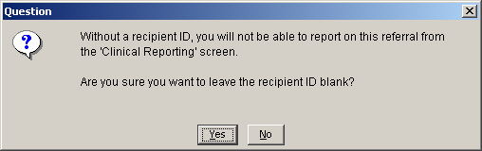

- You will also get a dialogue box showing the merge source and fields as below – ok this

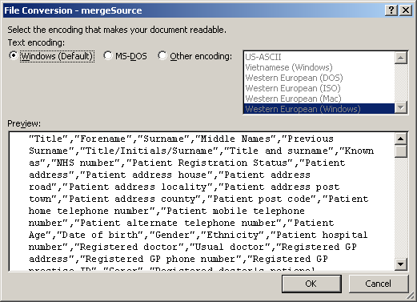

- This will now open a word mail merge document
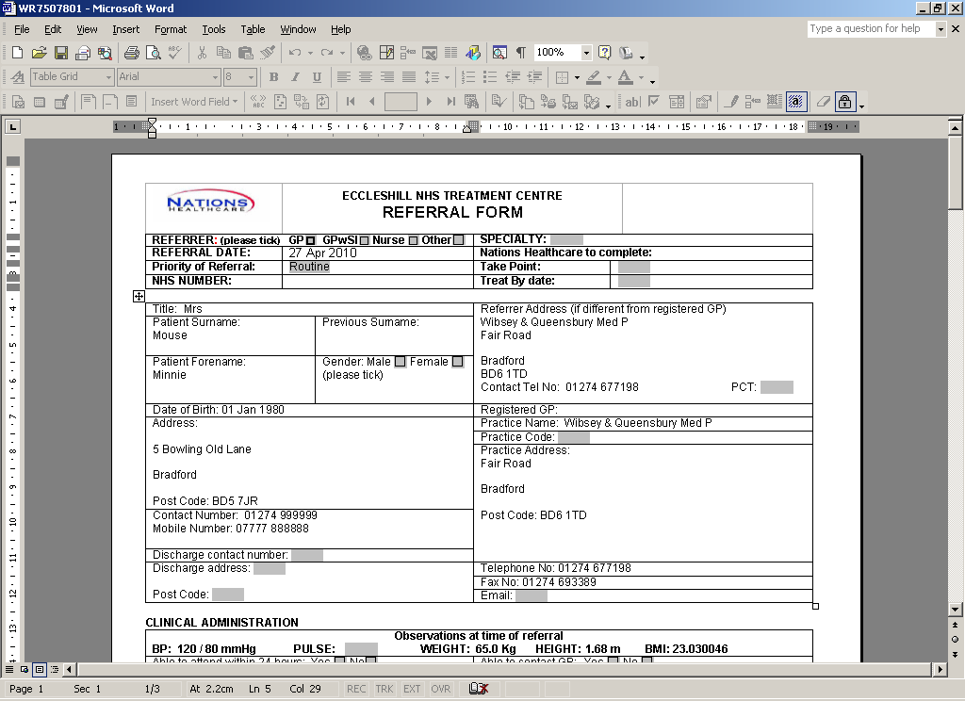

- If the document has been created as a form with tick boxes, it will be locked. All of the relevant patient information is imported into the document through the merge fields.

Before exiting out of the letter you will need to click on 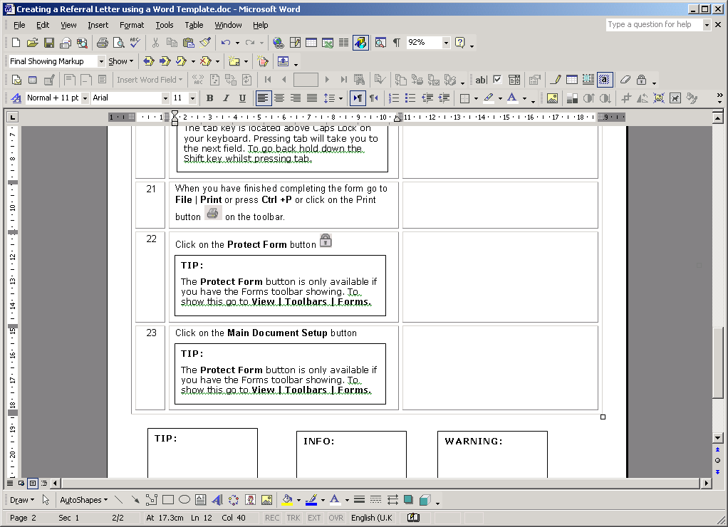 to make your template into a normal word document before closing or exiting out of SystmOne. There is an icon at the top right of the screen with a padlock, click on this once and it will release the mail merge tool bar.

Note: This will prevent the date or any other clinical information changing when you next access the letter or print out.

- It is now important to Save this letter, click on X to exit out of Word this will then prompt you to save the document. Click on Yes which will then return you back to SystmOne

3.1 Sending a Letter from a SystmOne Template

- Once “Write Now” has been clicked, the SystmOne Letter Editor window will appear. This window allows you to make any necessary changes to the letter as applicable to the individual patient you are working with.

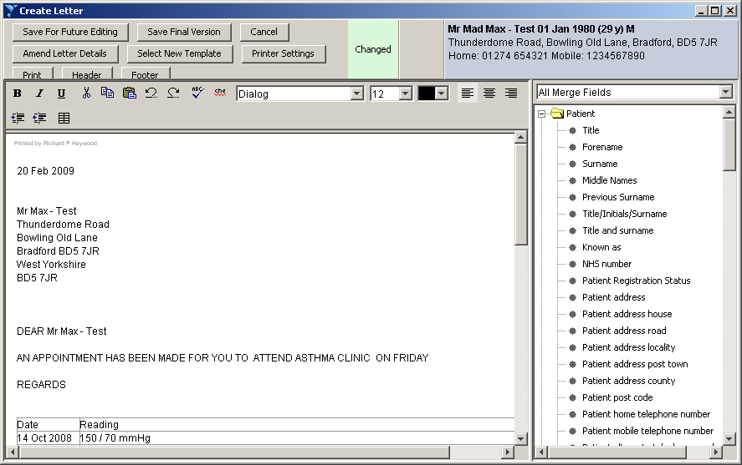

- This screen works in exactly the same way as when creating the initial template. Text can be added or removed, as can all merge fields from the list on the right hand side.

- Once any final changes have been made to the letter, there are two options that can be selected; “Save For Future Editing” and “Save Final Version.
- When selecting “Save for Future Editing”, Users are able to edit the document at a later time

- “Save Final Version” will not allow for any further changes to be made. This is to ensure that the Final Version as recorded on SystmOne is that same as the letter that the patient receives.

3.2 Sending a Letter from an MS Word Template

- Click onto the Communications/Letters icon on the Clinical Tree

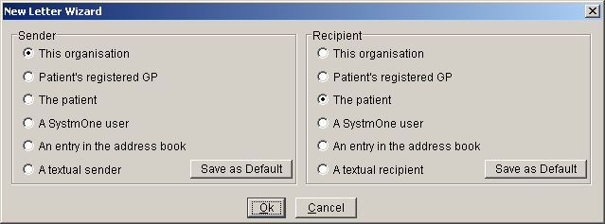

- The default is set to from This Organisation to The Patient
- Click ok

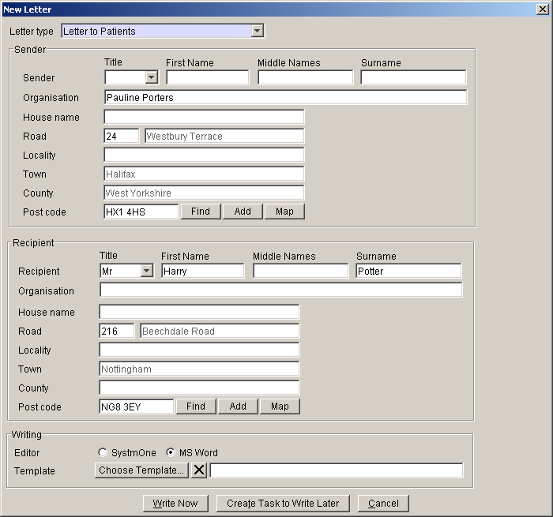

- Check that the Letter Type is correct and Sender and Recipient is correct. Then select the template from which system you have created them in – either SystmOne or MS Word and select Choose Template

- Once “Write Now” has been clicked, Microsoft Word will open, and the following prompt window will be displayed. These are information windows to say that the Merge Data will be pulled through from SystmOne. No actions need to be taken here, so click “Yes” to the first box and “OK” to the last box.

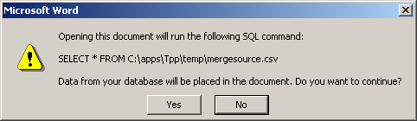

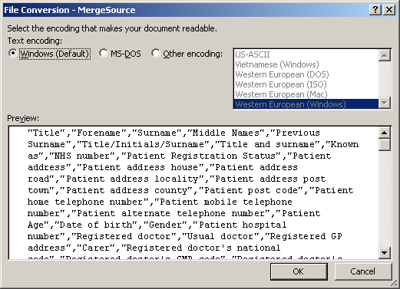

- The document is now opened in Microsoft Word or SystmOne as preference.

- It is now possible to amend any details in the letter as necessary. Any changes that are made will not be saved to the Template, but only to the individual patient’s record. Once any required changes are made, you are able to print the letter as usual.
.
- Before exiting out of the letter, if in MS Word, you will need to click on to make your template into a normal word document before closing or exiting out of SystmOne.

Note: This will prevent the date changing when you next access the letter or print out.

- It is now important to Save this letter, click on X to exit out of Word this will then prompt you to save the document. Click on Yes which will then return you back to SystmOne.

- When returning to SystmOne, the following window is displayed. If “Letter Sent” is selected, no further changes will be made to the letter in the patient record. However if “Amend Later” is selected, changes can be made at a later date, before it is sent or fully saved in the record.

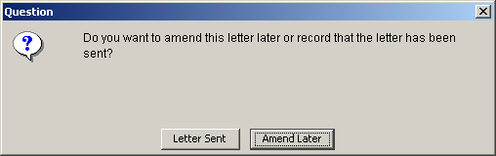

- The letter that has just been created will now appear in the list of previous letters in the patient record, along with some basic information.

- IMPORTANT: In order for the Letter to be saved, the Patient Record must now also be saved by clicking the “Save Record” Icon in SystmOne.
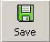

Appendix A: Referral Data Standards

When creating templates and/or letters in SystmOne, the Referral Data Standards need to be adhered to. The aim of the referral data standards is to advise and guide General Practices on what data items to include when generating a referral.

The data items detailed below form the basis of the Data Standards for Referrals. The merge fields listed in the right-hand column are found in the merge data pulled from SystmOne

Data Standard | Merge Field to include
Patient Identifier | NHS Number
Patient Demographics | Surname  Forename  Address  Postcode  Contact telephone numbers
Special Requirements | Transport needs  Interpreter required
Patient Profiling | Ethnicity  Language
Referrer | Name of referring practitioner  Name of referring practice
Service required | Name of the speciality you are referring to
Urgency | Urgent  Routine
Reason for referral | Body of text
Past Medical History | Allergies and sensitivities  Current summary / problems  Family history
Medication | Recent Acute  Current repeat templates
Biometric Values | Latest height  Latest weight  Latest BMI  BP reading
Relevant Test Results | Recent relevant test results
Consent to Share | Patient’s consent status

Should you have any further questions relating to the usage of Referral Data Standards, please contact the Data Quality Team at Douglas Mill.

